**LABORATORY PROGRAM – 2**

Develop a Java program to create a class Student with members usn, name, an array credits and an array marks. Include methods to accept and display details and a method to calculate SGPA of a student.

**OBSERVATION :**

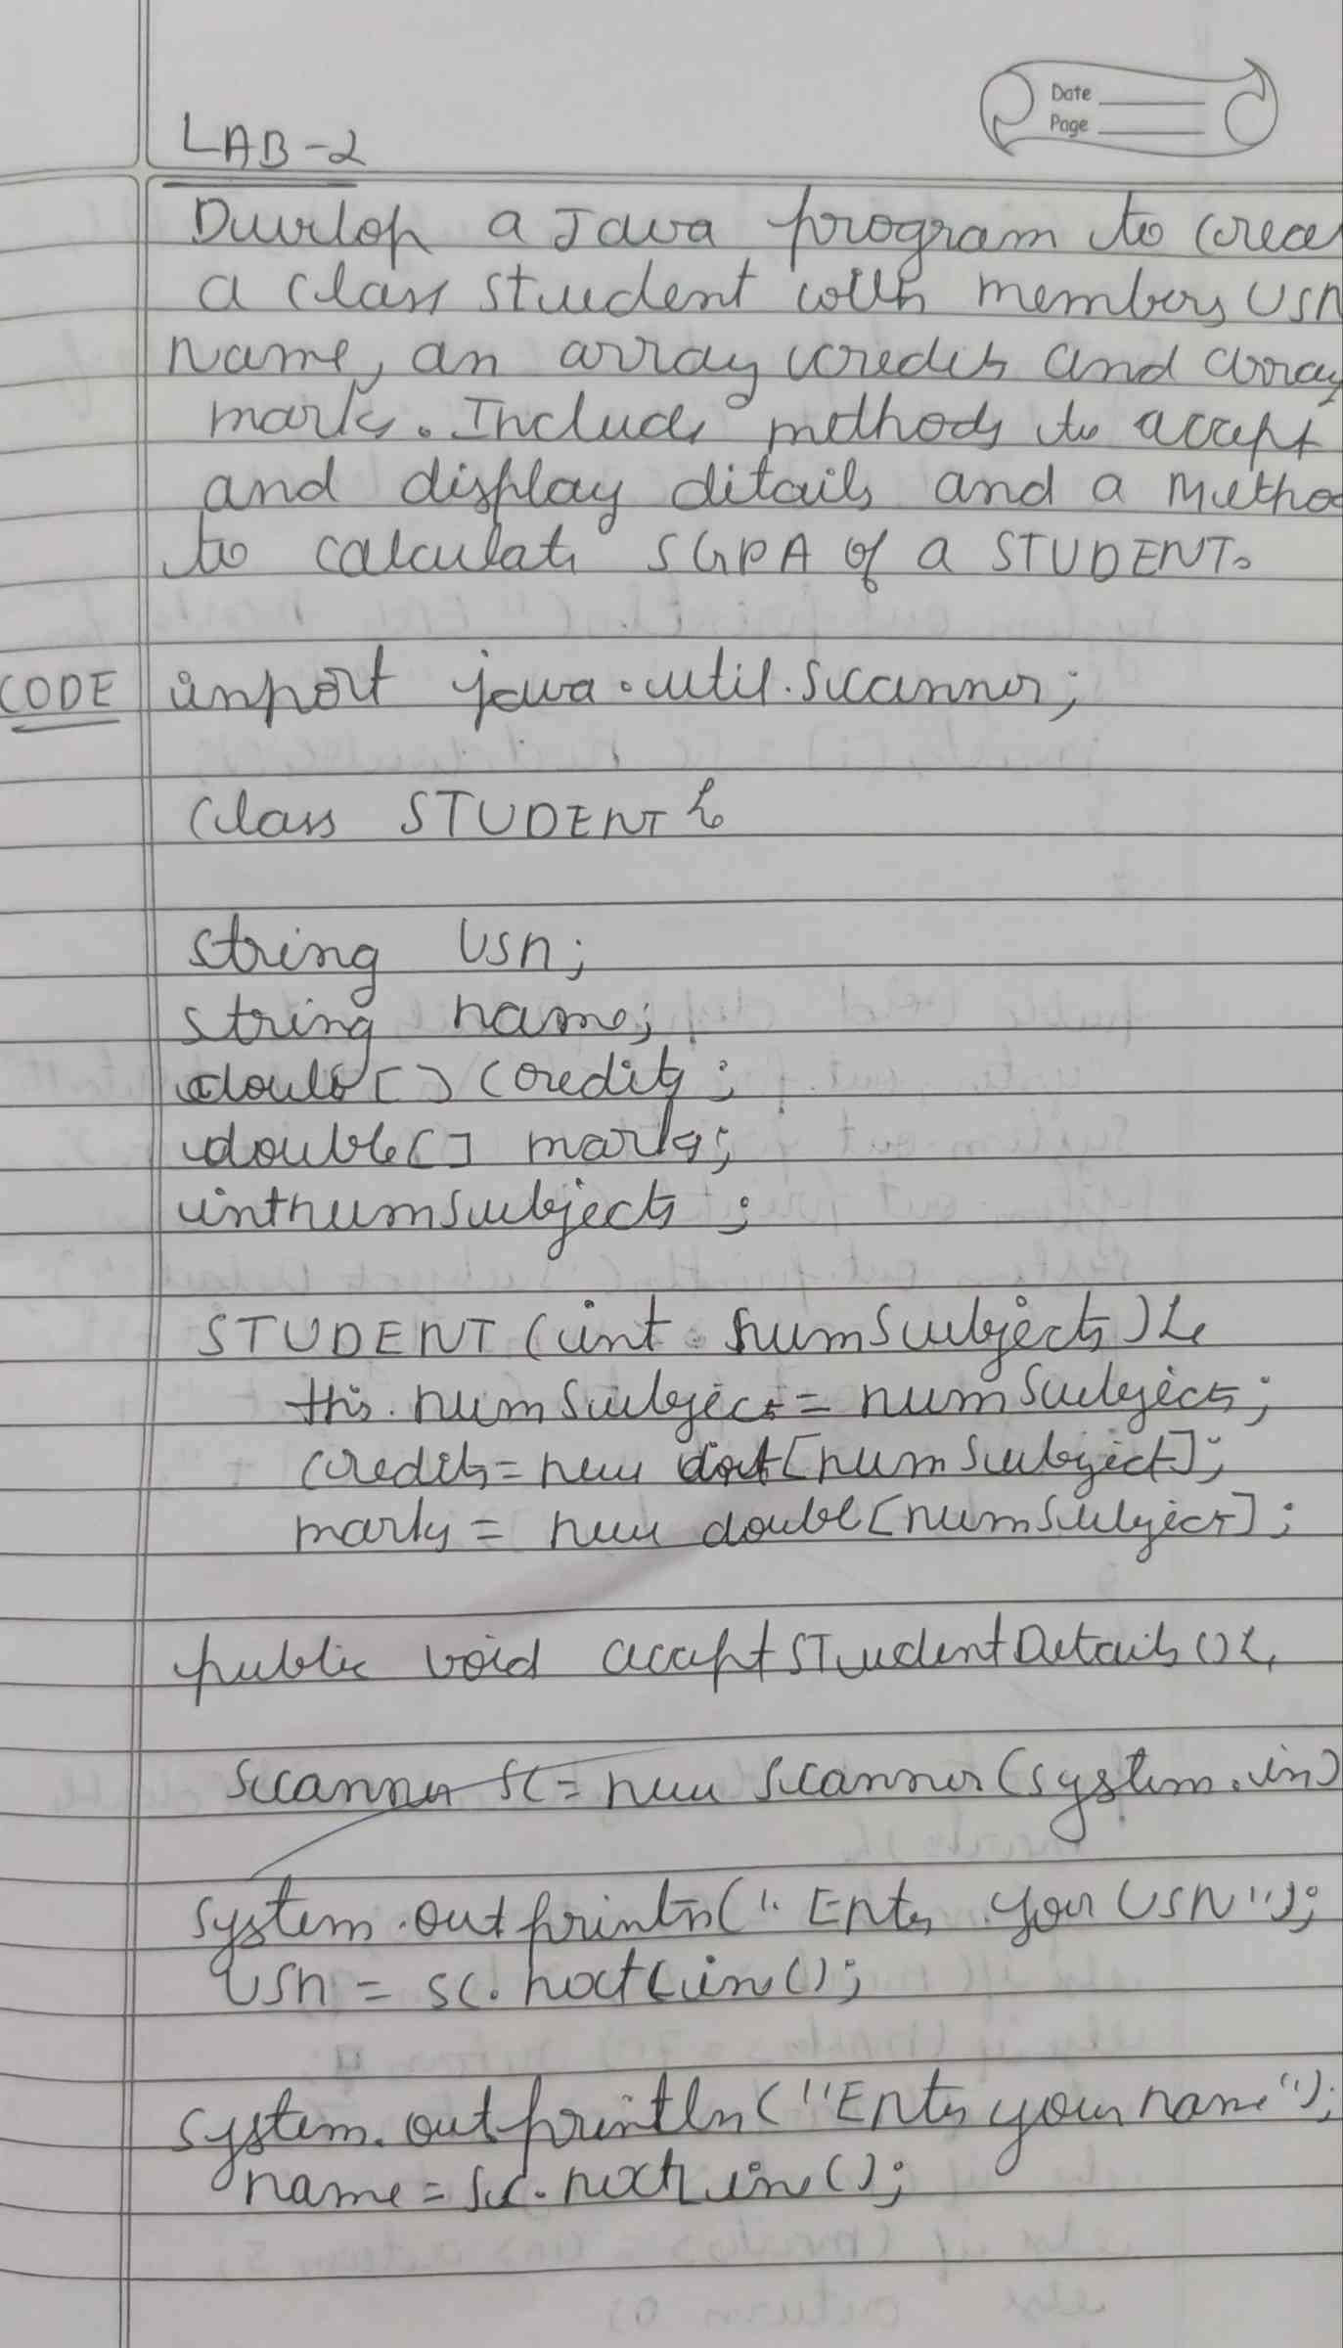

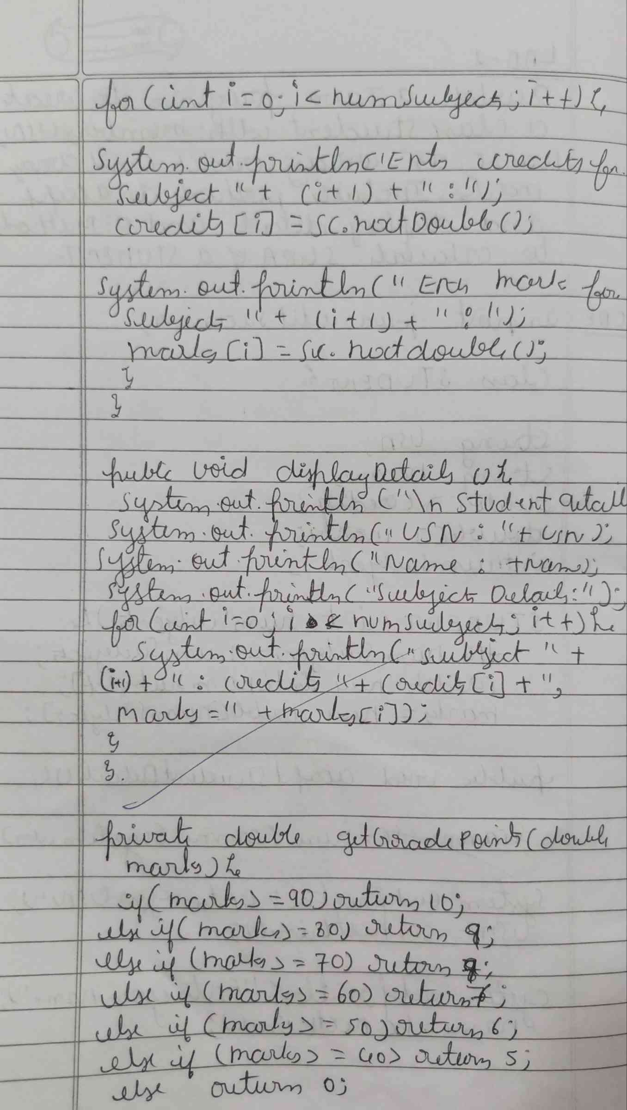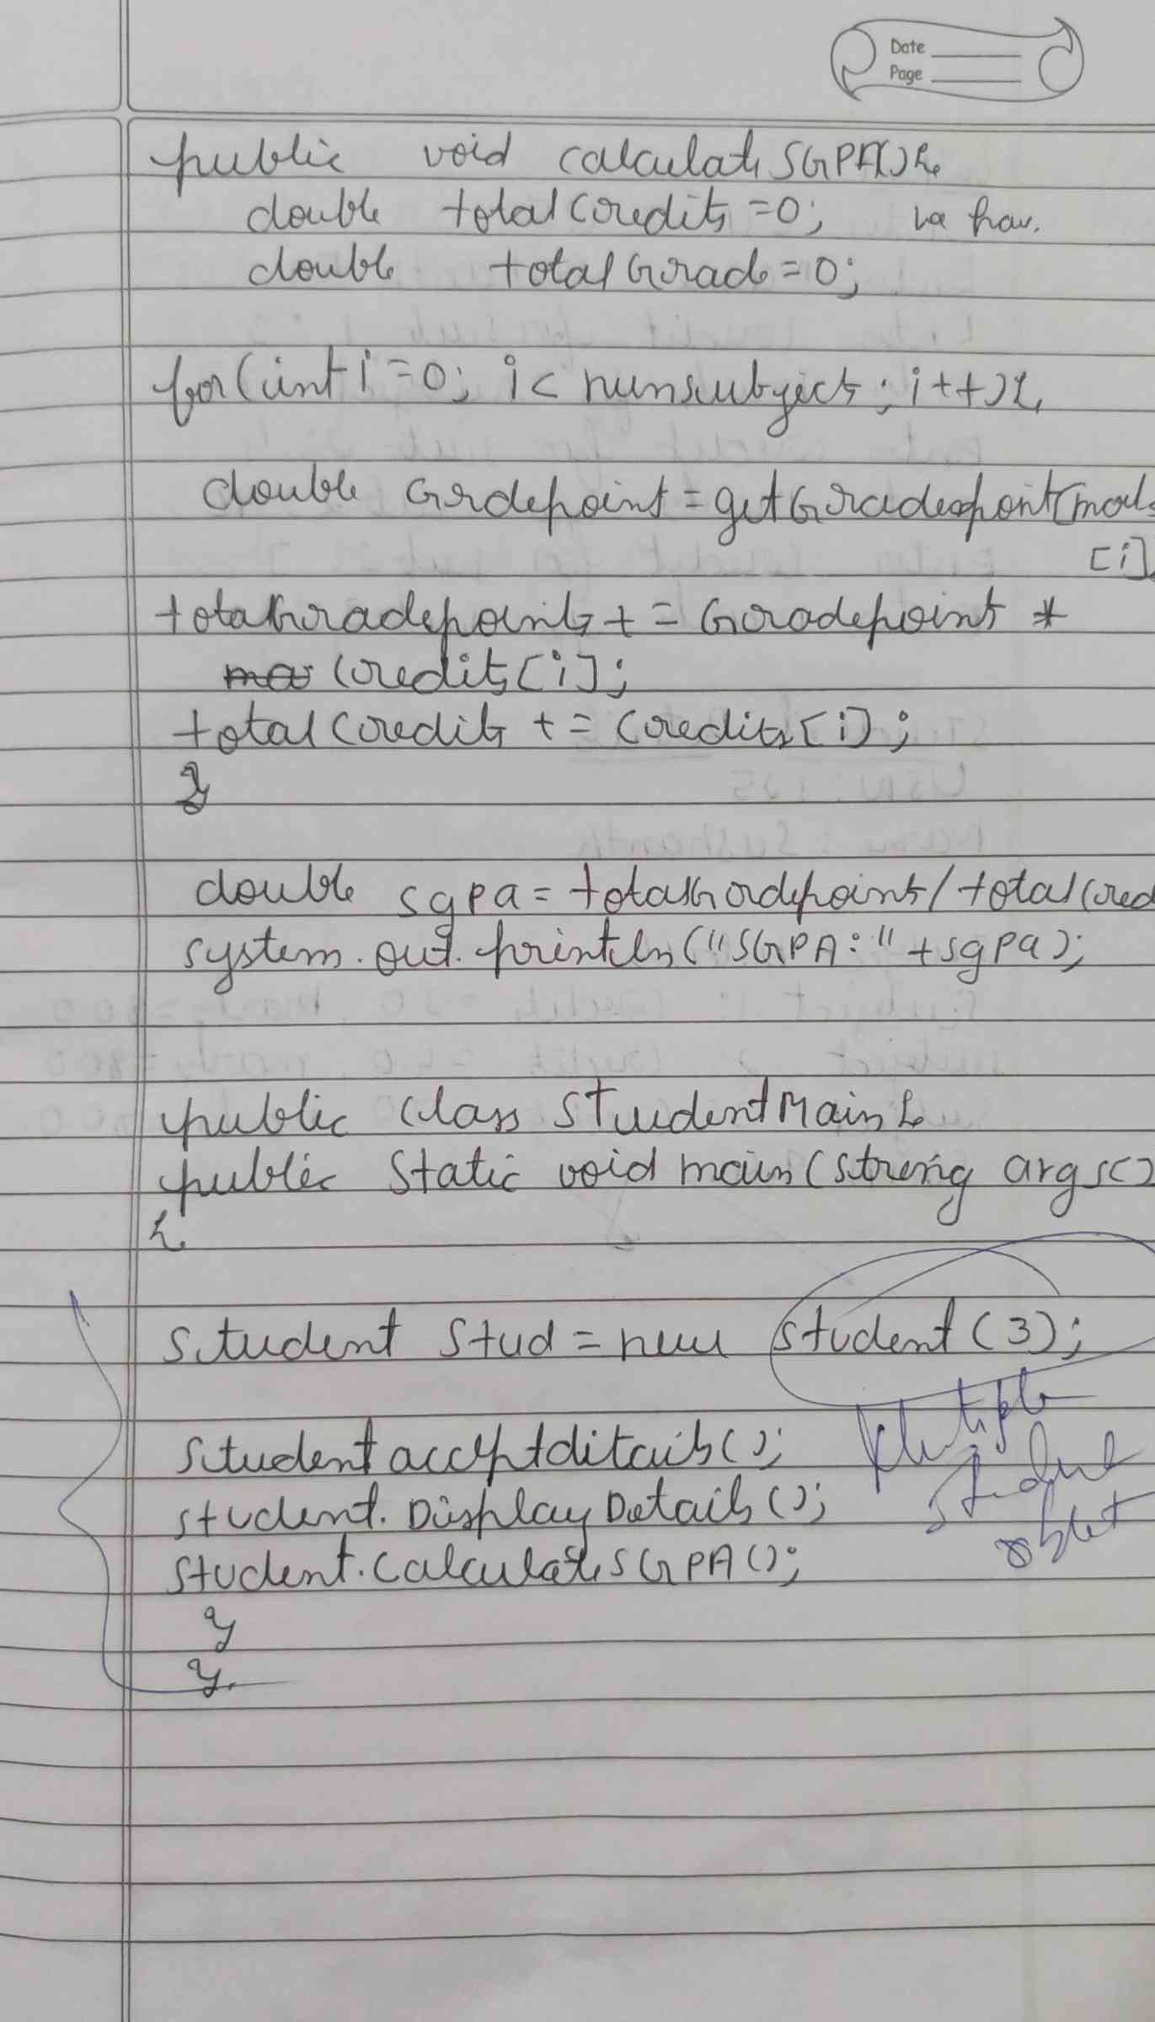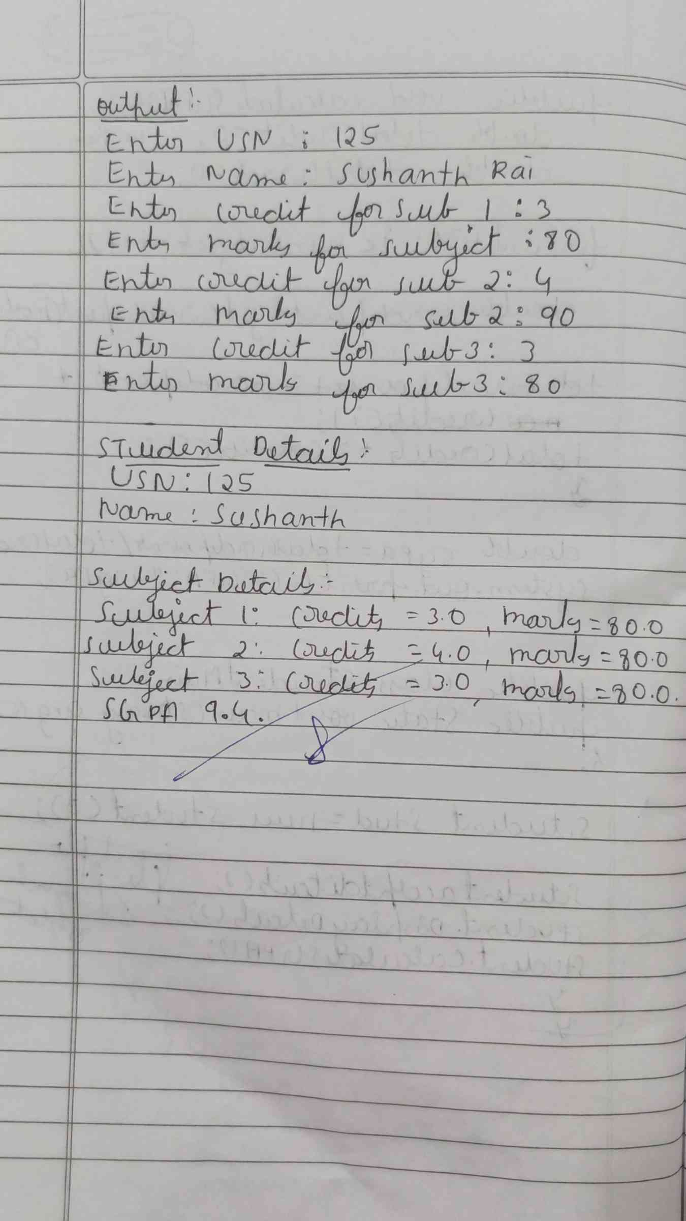

**CODE :**

import java.util.Scanner;

class Student {

    String usn;

    String name;

    double[] credits;

    double[] marks;

    int numSubjects

    Student(int numSubjects) {

        this.numSubjects = numSubjects;

        credits = new double[numSubjects];

        marks = new double [numSubjects];

    }

    public void acceptDetails() {

        Scanner scanner = new Scanner(System.in);

        System.out.print("Enter USN: ");

        usn = scanner.nextLine();

        System.out.print("Enter Name: ");

        name = scanner.nextLine();

        for (int i = 0; i < numSubjects; i++) {

            System.out.print("Enter credits for subject " + (i+1) + ": ");

            credits[i] = scanner.nextDouble();

            System.out.print("Enter marks for subject " + (i+1) + ": ");

            marks[i] = scanner.nextDouble();}}

    public void displayDetails() {

        System.out.println("\nStudent Details:");

        System.out.println("USN: " + usn);

        System.out.println("Name: " + name);

        System.out.println("Subjects Details: ");

        for (int i = 0; i < numSubjects; i++) {

            System.out.println("Subject " + (i+1) + ": Credits = " + credits[i] + ", Marks = " + marks[i]);}  }

    public void calculateSGPA() {

        double totalCredits = 0;

        double totalGradePoints = 0;

        for (int i = 0; i < numSubjects; i++) {

            double gradePoint = getGradePoint(marks[i]);

            totalGradePoints += gradePoint * credits[i];

            totalCredits += credits[i];

        }

        double sgpa = totalGradePoints / totalCredits;

        System.out.println("SGPA: " + sgpa);}

    private double getGradePoint(double marks) {

        if (marks >= 90) return 10;

        else if (marks >= 80) return 9;

        else if (marks >= 70) return 8;

        else if (marks >= 60) return 7;

        else if (marks >= 50) return 6;

        else if (marks >= 40) return 5;

        else return 0;  }

public class StudentMain {

    public static void main(String[] args) {

        Student student = new Student(3);

        student.acceptDetails();

        student.displayDetails();

        student.calculateSGPA();

    }

}

**OUTPUT :**

